A000-Eur-Greece-Alexander the Great-Coins

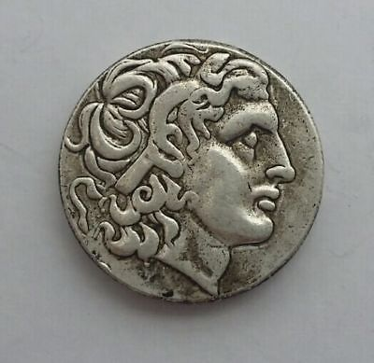 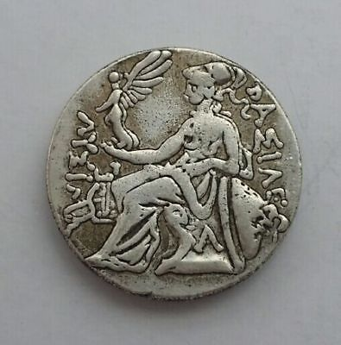

Alexander III the Great 336-323 BC Silver Drachm

|  |  |
| --- | --- |
| **Alexander the Great** | |
| [*Basileus*](https://en.wikipedia.org/wiki/Basileus)*of*[*Macedon*](https://en.wikipedia.org/wiki/Macedon)*,*[*Hegemon*](https://en.wikipedia.org/wiki/Hegemony)*of the*[*Hellenic League*](https://en.wikipedia.org/wiki/League_of_Corinth)*, [Shahanshah](https://en.wikipedia.org/wiki/Shahanshah" \o "Shahanshah) of*[*Persia*](https://en.wikipedia.org/wiki/Persia)*,*[*Pharaoh*](https://en.wikipedia.org/wiki/Pharaoh)*of*[*Egypt*](https://en.wikipedia.org/wiki/Ancient_Egypt)*,*[*Lord of Asia*](https://en.wikipedia.org/wiki/Lord_of_Asia)   * Ἀλέξανδρος ὁ Μέγας (*Aléxandros ho Mégas*, Alexander the Great)   During his youth, Alexander was tutored by [Aristotle](https://en.wikipedia.org/wiki/Aristotle) until age 16. After Philip's assassination in 336 BC, he succeeded his father to the throne and inherited a strong kingdom and an experienced army. Alexander was awarded the [generalship of Greece](https://en.wikipedia.org/wiki/League_of_Corinth) and used this authority to launch his father's pan-Hellenic project to lead the Greeks in the conquest of [Persia](https://en.wikipedia.org/wiki/Persia). In 334 BC, he invaded the [Achaemenid Empire](https://en.wikipedia.org/wiki/Achaemenid_Empire" \o "Achaemenid Empire) (Persian Empire) and began a [series of campaigns](https://en.wikipedia.org/wiki/Wars_of_Alexander_the_Great) that lasted ten years. Following the conquest of [Anatolia](https://en.wikipedia.org/wiki/Anatolia), Alexander broke the power of Persia in a series of decisive battles, most notably the battles of [Issus](https://en.wikipedia.org/wiki/Battle_of_Issus) and [Gaugamela](https://en.wikipedia.org/wiki/Battle_of_Gaugamela). He subsequently overthrew Persian King [Darius III](https://en.wikipedia.org/wiki/Darius_III) and conquered the Achaemenid Empire in its entirety.  At that point, his empire stretched from the [Adriatic Sea](https://en.wikipedia.org/wiki/Adriatic_Sea) to the [Indus River](https://en.wikipedia.org/wiki/Indus_River).   |  |  |  |  | | --- | --- | --- | --- | |  | |  |  | | --- | --- | |  |  | | | |
| [Alexander the Great mosaic.jpg](https://en.wikipedia.org/wiki/File:Alexander_the_Great_mosaic.jpg)  [Alexander Mosaic](https://en.wikipedia.org/wiki/Alexander_Mosaic) (c. first century CE), ancient Roman floor mosaic from the [House of the Faun](https://en.wikipedia.org/wiki/House_of_the_Faun)in [Pompeii](https://en.wikipedia.org/wiki/Pompeii) showing Alexander fighting king [Darius III of Persia](https://en.wikipedia.org/wiki/Darius_III) in the [Battle of Issus](https://en.wikipedia.org/wiki/Battle_of_Issus). | |
| [**King of Macedonia**](https://en.wikipedia.org/wiki/List_of_kings_of_Macedon) | |
| **Reign** | 336–323 BC |
| **Predecessor** | [Philip II](https://en.wikipedia.org/wiki/Philip_II_of_Macedon) |
| **Successor** | [Alexander IV](https://en.wikipedia.org/wiki/Alexander_IV_of_Macedon) [Philip III](https://en.wikipedia.org/wiki/Philip_III_of_Macedon) |
| [**Pharaoh of Egypt**](https://en.wikipedia.org/wiki/Pharaoh) | |
| **Reign** | 332–323 BC |
| **Predecessor** | [Darius III](https://en.wikipedia.org/wiki/Darius_III) |
| **Successor** | [Alexander IV](https://en.wikipedia.org/wiki/Alexander_IV_of_Macedon) [Philip III](https://en.wikipedia.org/wiki/Philip_III_of_Macedon) |
| [**King of Persia**](https://en.wikipedia.org/wiki/List_of_kings_of_Persia) | |
| **Reign** | 330–323 BC |
| **Predecessor** | [Darius III](https://en.wikipedia.org/wiki/Darius_III) |
| **Successor** | [Alexander IV](https://en.wikipedia.org/wiki/Alexander_IV_of_Macedon) [Philip III](https://en.wikipedia.org/wiki/Philip_III_of_Macedon) |
| [**Lord of Asia**](https://en.wikipedia.org/wiki/Lord_of_Asia) | |
| **Reign** | 331–323 BC |
| **Predecessor** | *New office* |
| **Successor** | [Alexander IV](https://en.wikipedia.org/wiki/Alexander_IV_of_Macedon) [Philip III](https://en.wikipedia.org/wiki/Philip_III_of_Macedon) |
|  | |
| **Born** | 20 or 21 July 356 BC [Pella](https://en.wikipedia.org/wiki/Pella), [Macedon](https://en.wikipedia.org/wiki/Macedon), [Ancient Greece](https://en.wikipedia.org/wiki/Ancient_Greece) |
| **Died** | 10 or 11 June 323 BC (aged 32) [Babylon](https://en.wikipedia.org/wiki/Babylon) |
| **Spouse** | [Roxana](https://en.wikipedia.org/wiki/Roxana) of [Bactria](https://en.wikipedia.org/wiki/Bactria) [Stateira II](https://en.wikipedia.org/wiki/Stateira_II) of [Persia](https://en.wikipedia.org/wiki/Persia) [Parysatis II](https://en.wikipedia.org/wiki/Parysatis_II) of Persia |
| **Issue** | [Alexander IV](https://en.wikipedia.org/wiki/Alexander_IV_of_Macedon) |
|  | |
|  |  |
|  |  |